+ANUDIP FOUNDATION
A Project Report on
FOOD DELIVERY MANAGEMENT SYSTEM
By
Batch: ANP-D0453
Student ID: AF0477090
Name: Rakshita Chormale
Under the Guidance of
Mrs. Rajshri Chandrabhan Thete

FOOD DELIVERY MANAGEMENT SYSTEM
A Food Delivery Management System (FDMS) is a software solution designed to streamline the food delivery process for restaurants, food establishments, and delivery services. The system aims to improve efficiency, reduce costs, and enhance customer satisfaction.
Entities:
- Admin
- Customer
- Food
- Orders
- Payment
- Delivery Boy
- Category

ATTRIBUTES OF ENTITIES:

- Admin
- Attributes:
- AdminID (primary key)
- Name
- Email_ID
- Contact_No
- Password

- Customer
- Attributes:
- CustomerID (primary key)
- Name
- Email_ID
- Contact_No
- Address

- Food
- Attributes:
- FoodID (primary key)
- Price
- Name
- Description
- Quantity

- Orders
- Attributes:
- OrderID (primary key)
- OrderDate
- Time
- OrderStatus

- Payment
- Attributes:
- PaymentID (primary key)
- Date
- PaymentMethod

- Delivery Boy
- Attributes:
- DeliveryBoy_ID (primary key)
- Name
- Contact_No

- Category
- Attributes:
- ID(primary key)
- Veg
- Non-Veg

ENTITY RELATIONSHIP DIAGRAM – FOOD DELIVERY MANAGEMENT SYSTEM

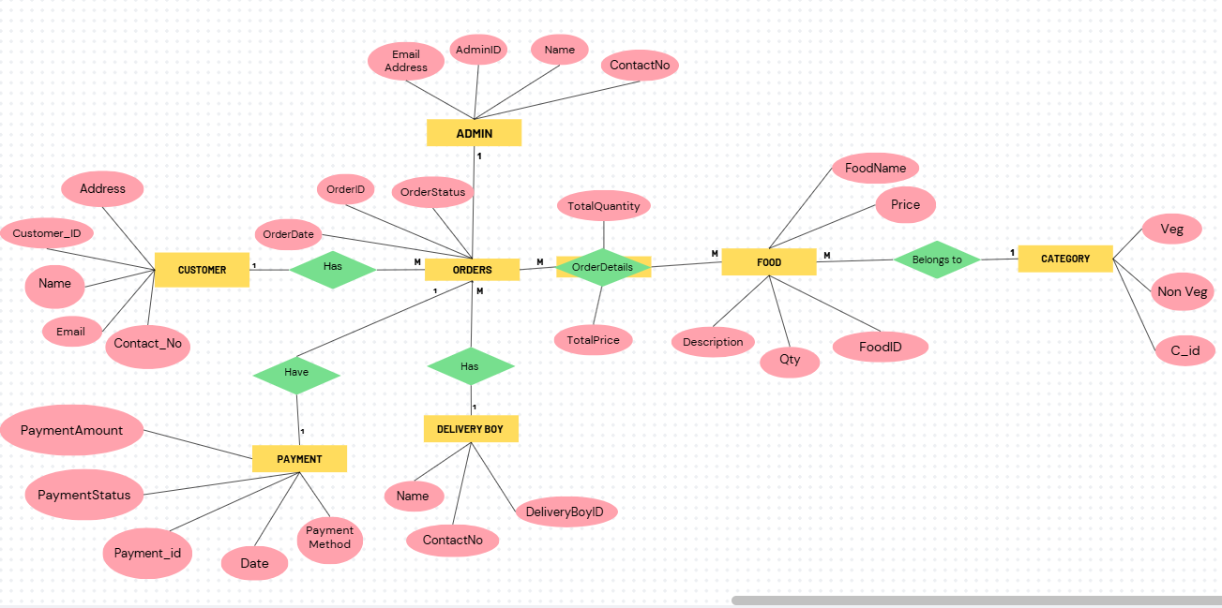

Database Creation Query :

mysql> show databases;
+---------------------+
| Database |
+---------------------+
| anp_d0453 |
| anp_java |
| food_order |
| fooddelivery |
| foodordering_system |
| information_schema |
| mysql |
| performance_schema |
| sakila |
| student_mgt_system |
| sys |
| world |
+---------------------+
12 rows in set (0.00 sec)

mysql> use fooddelivery;
Database changed
mysql> show tables;
+------------------------+
| Tables_in_fooddelivery |
+------------------------+
| admin |
| categories |
| customer |
| delivery_boy |
| food |
| orders |
| payment |
+------------------------+
7 rows in set (0.00 sec)

mysql> desc admin;
+--------------+-------------+------+-----+---------+-------+
| Field | Type | Null | Key | Default | Extra |
+--------------+-------------+------+-----+---------+-------+
| AdminID | varchar(10) | NO | PRI | NULL | |
| ContactNo | varchar(20) | YES | | NULL | |
| EmailAddress | varchar(20) | YES | | NULL | |
| Name | varchar(20) | YES | | NULL | |
+--------------+-------------+------+-----+---------+-------+
4 rows in set (0.00 sec)

mysql> desc categories;
+---------+-------------+------+-----+---------+-------+
| Field | Type | Null | Key | Default | Extra |
+---------+-------------+------+-----+---------+-------+
| ID | varchar(10) | NO | PRI | NULL | |
| Non_Veg | varchar(20) | YES | | NULL | |
| Veg | varchar(10) | YES | | NULL | |
+---------+-------------+------+-----+---------+-------+
3 rows in set (0.00 sec)

mysql> desc customer;
+------------+-------------+------+-----+---------+-------+
| Field | Type | Null | Key | Default | Extra |
+------------+-------------+------+-----+---------+-------+
| CustomerID | varchar(10) | NO | PRI | NULL | |
| Address | varchar(30) | YES | | NULL | |
| ContactNo | varchar(20) | YES | | NULL | |
| Email_ID | varchar(30) | YES | | NULL | |
| Name | varchar(30) | YES | | NULL | |
+------------+-------------+------+-----+---------+-------+
5 rows in set (0.00 sec)

mysql> desc delivery_boy;
+----------------+-------------+------+-----+---------+-------+
| Field | Type | Null | Key | Default | Extra |
+----------------+-------------+------+-----+---------+-------+
| DeliveryBoy_ID | varchar(10) | NO | PRI | NULL | |
| ContactNo | varchar(20) | YES | | NULL | |
| Name | varchar(30) | YES | | NULL | |
+----------------+-------------+------+-----+---------+-------+
3 rows in set (0.00 sec)

mysql> desc food;
+-------------+-------------+------+-----+---------+-------+
| Field | Type | Null | Key | Default | Extra |
+-------------+-------------+------+-----+---------+-------+
| FoodID | varchar(10) | NO | PRI | NULL | |
| Description | varchar(50) | YES | | NULL | |
| FoodName | varchar(20) | YES | | NULL | |
| Price | varchar(20) | YES | | NULL | |
| Quantity | varchar(20) | YES | | NULL | |
+-------------+-------------+------+-----+---------+-------+
5 rows in set (0.00 sec)

mysql> desc orders;
+--------------+-------------+------+-----+---------+-------+
| Field | Type | Null | Key | Default | Extra |
+--------------+-------------+------+-----+---------+-------+
| OrderID | varchar(10) | NO | PRI | NULL | |
| OrderDate | varchar(20) | YES | | NULL | |
| OrderStatus | varchar(20) | YES | | NULL | |
+--------------+-------------+------+-----+---------+-------+
4 rows in set (0.00 sec)

mysql> desc payment;
+---------------+-------------+------+-----+---------+-------+
| Field | Type | Null | Key | Default | Extra |
+---------------+-------------+------+-----+---------+-------+
| PaymentID | varchar(10) | NO | PRI | NULL | |
| PaymentAmount | varchar(50) | YES | | NULL | |
| PaymentDate | varchar(10) | YES | | NULL | |
| PaymentMethod | varchar(20) | YES | | NULL | |
| PaymentStatus | varchar(20) | YES | | NULL | |
+---------------+-------------+------+-----+---------+-------+
5 rows in set (0.00 sec)

CONCLUSION:
In summary, the implementation of a Food Delivery Management System can have a transformative impact on the food delivery industry. By leveraging its features and benefits, businesses can enhance customer experiences, increase efficiency, and drive growth. As the food delivery market continues to evolve, the adoption of FDMS will become increasingly essential for businesses seeking to remain competitive and thrive in this dynamic landscape. A Food Delivery Management System is a crucial tool for food establishments and delivery services seeking to improve operational efficiency, customer satisfaction, and revenue growth. By streamlining order management, delivery logistics, and customer interactions, FDMS enables businesses to stay competitive in the rapidly evolving food delivery market.

